Project Plan Process

# Introduction

The project planning process that will be applied for the built of this project is agile as an iterative approach to the project management and the software development.

The software tool to be used to help the management of the project work flow is *Jira Software*

Jira link: (invitations are sent to all the teachers involved)

[IT board - Roadmap - Jira (atlassian.net)](https://ismailchbiki.atlassian.net/jira/software/c/projects/IT/boards/5/roadmap?selectedIssue=IT-26)

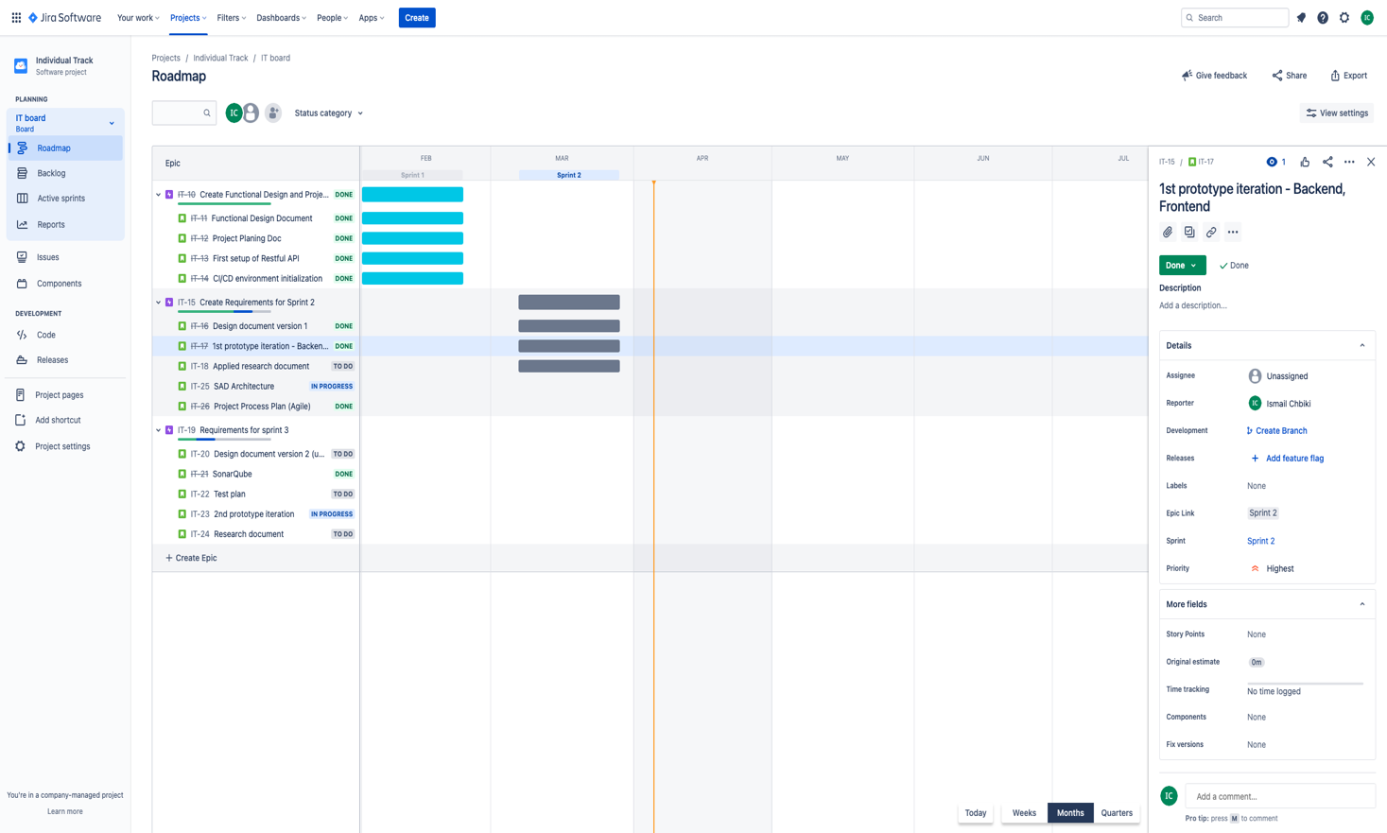

*Screenshot from my account*